UNAUDITED FOURTH QUARTER REPORT ENDED 30 JUNE 2005
CONDENSED CONSOLIDATED BALANCE SHEETS

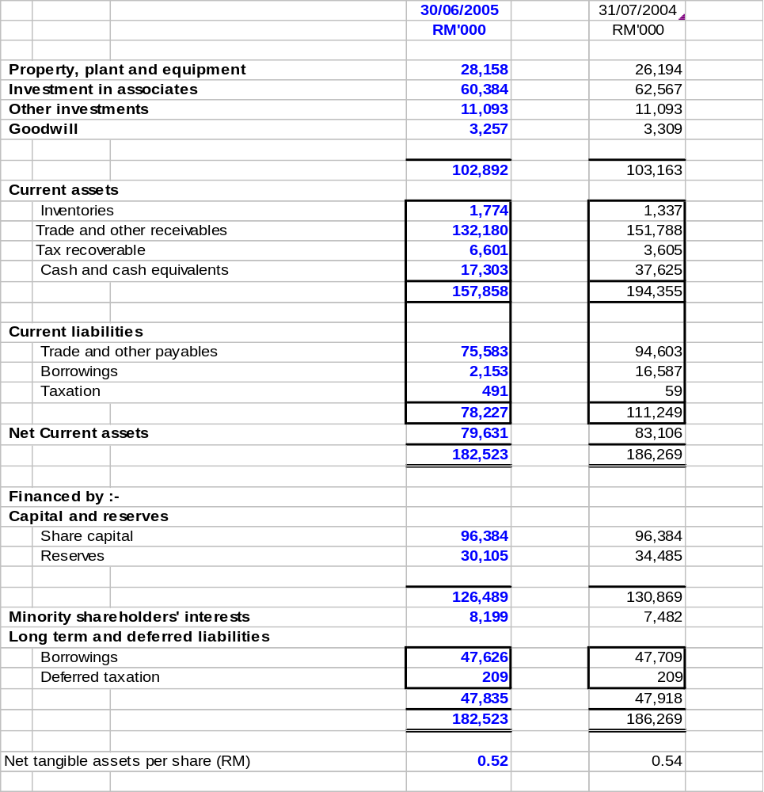

The Condensed Consolidated Balance Sheets should be read in conjunction with the Annual Financial Statements for the year ended 31 July 2004.

UNAUDITED FOURTH QUARTER REPORT ENDED 30 JUNE 2005

CONDENSED CONSOLIDATED INCOME STATEMENTS

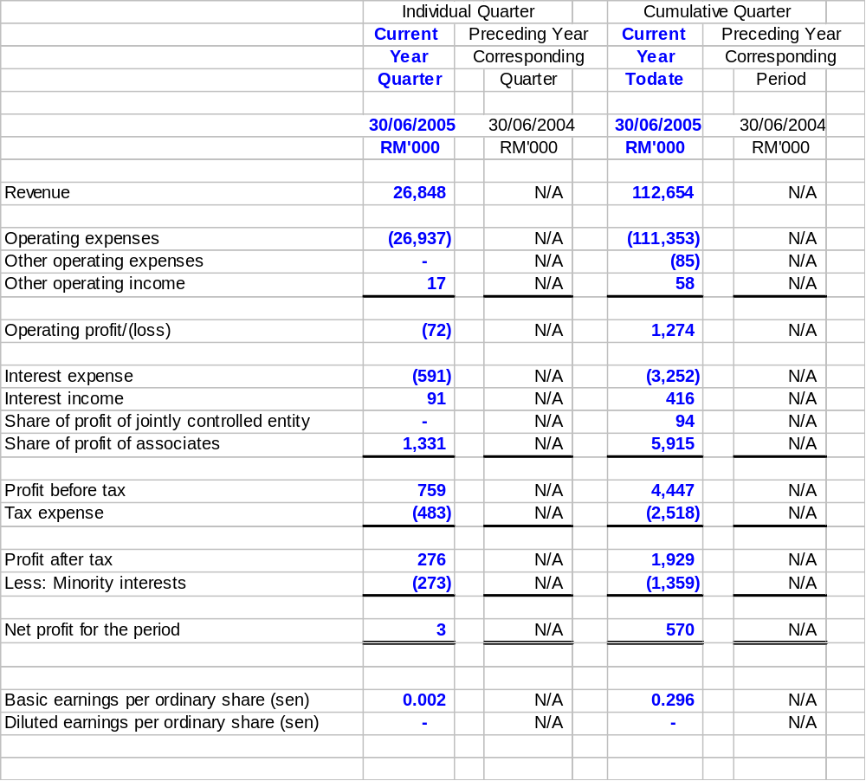
Note:
The comparative figures are not applicable due to the change of financial year as detailed in Note A1. The current quarter announcement is for 2 months period, from 1 May 2005 to 30 June 2005.

The Condensed Consolidated Income Statements should be read in conjunction with the Annual Financial Statements for the year ended 31 July 2004.

UNAUDITED FOURTH QUARTER REPORT ENDED 30 JUNE 2005

CONDENSED CONSOLIDATED STATEMENT OF CHANGES IN EQUITY

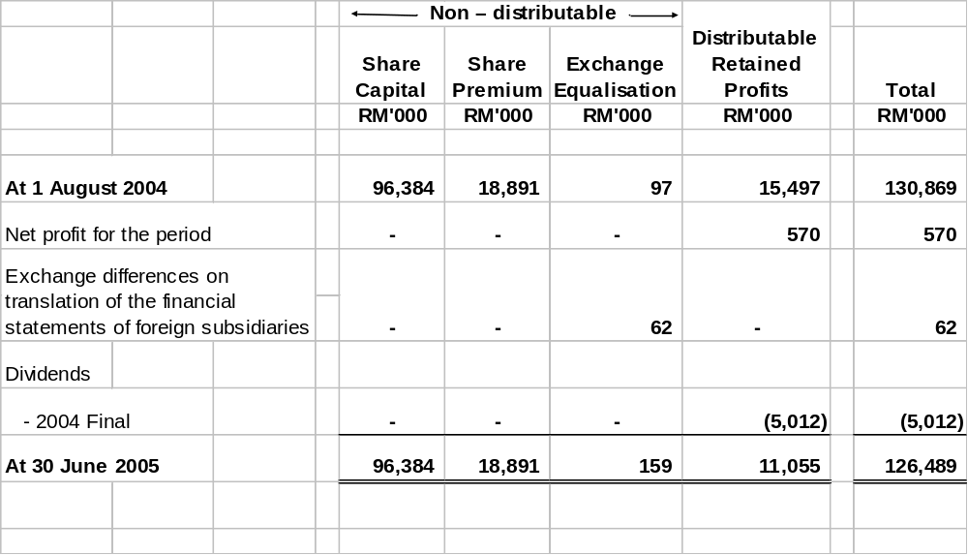

Note:
The comparative figures are not applicable due to the change of financial year as detailed in Note A1.

The current quarter announcement is for 2 months period, from 1 May 2005 to 30 June 2005.

[THE REST OF THIS PAGE IS INTENTIONALLY LEFT BLANK]

The Condensed Consolidated Statement of Changes in Equity should be read in conjunction with the Annual Financial Statements for the year ended 31 July 2004.

UNAUDITED FOURTH QUARTER REPORT ENDED 30 JUNE 2005
CONDENSED CONSOLIDATED CASHFLOW STATEMENT

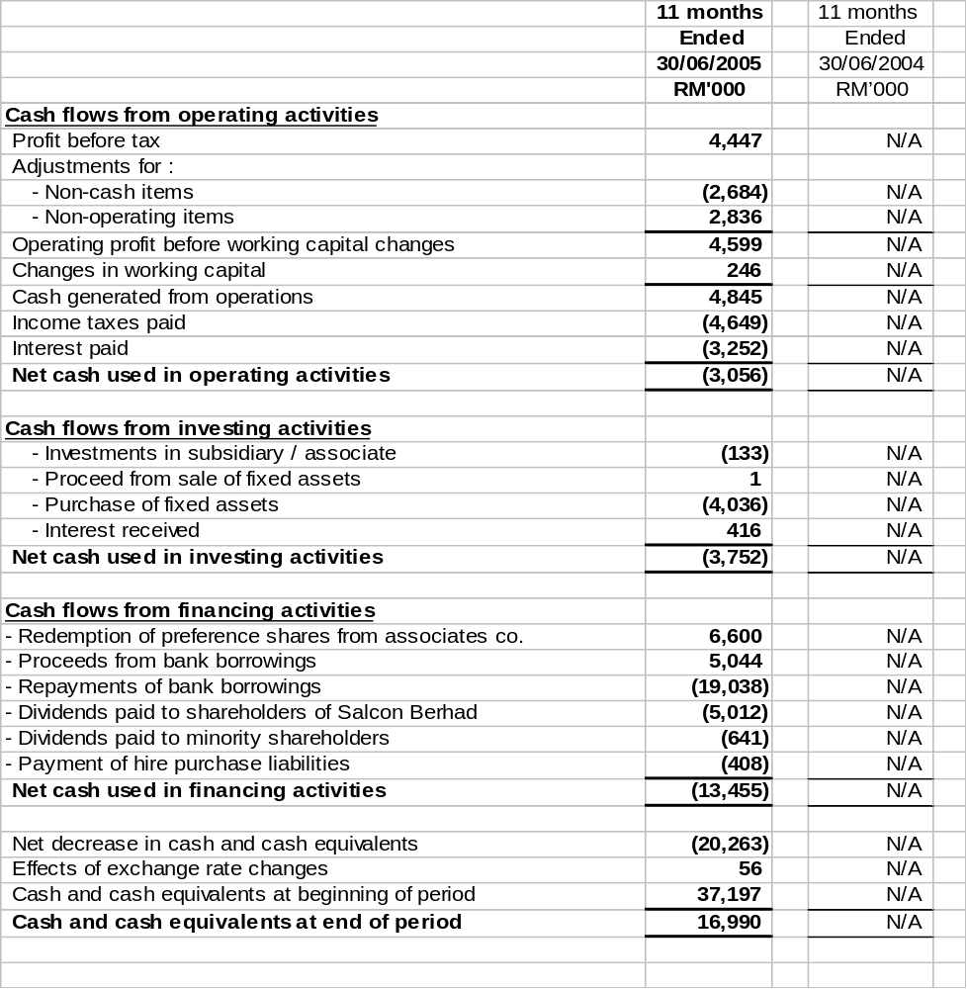

The cash and cash equivalents comprise the following balance sheet amounts :

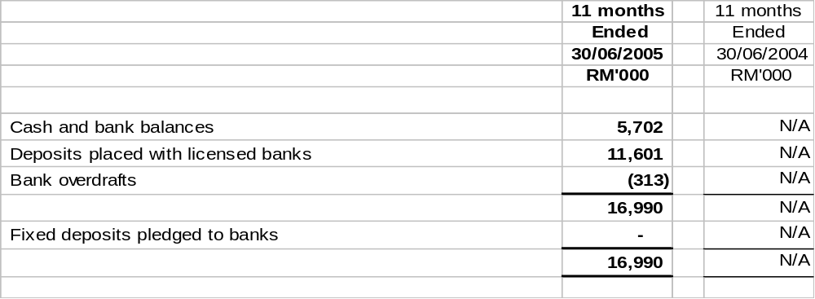
Note:
The comparative figures are not applicable due to the change of financial year as detailed in Note A1.
The current quarter announcement is for 2 months period, from 1 May 2005 to 30 June 2005.

[THE REST OF THIS PAGE IS INTENTIONALLY LEFT BLANK]

The Condensed Consolidated Cash Flow Statement should be read in conjunction with the Annual Financial Statements for the year ended 31 July 2004.

NOTES TO THE INTERIM FINANCIAL REPORT FOR THE FOURTH QUARTER ENDED 30 JUNE 2005

- DISCLOSURE REQUIREMENTS AS PER FRS 134 – Interim Financial Reporting (formerly known as MASB 26)

- Basis of Accounting and Accounting Policies

The interim financial statements have been prepared in accordance with FRS 134 – Interim Financial Reporting (formerly known as MASB 26) and Chapter 9 Part K of the Listing Requirements of Bursa Malaysia Securities Berhad (BMSB).

The interim financial report should be read in conjunction with the annual financial statements of the Group for the financial year ended 31 July 2004.

The accounting policies and methods of computation adopted by the Group in this interim financial report are consistent with those adopted in the annual financial statements for the financial year ended 31 July 2004.

As announced on 28 June 2005, the Company has changed its financial year-end from the existing 31 July to 31 December. The comparative figures are not applicable for the current financial period due to the change of financial year end.

Due to the above-mentioned change of the financial year end, the current quarter announcement is for 2 months period, that is, from 1 May 2005 to 30 June 2005.

- Preceding Annual Financial Statement

The audit report of the Group’s annual financial statements for the year ended 31 July 2004 was not subject to any qualification.

- Seasonal or Cyclical Factors

The principal activities of the Group are not subject to any seasonal or cyclical changes.

- Exceptional and Extraordinary Items

There were no exceptional and extraordinary items of an unusual nature affecting the assets, liabilities, equity, net income or cashflows of the Group for the current quarter.

- Material Changes in Estimates

There were no changes in the estimates of amounts reported in prior interim periods of the current financial period or changes in estimates of amounts reported in prior financial years that have a material effect in the current interim period.

- Debt and Equity Securities

There were no issuance and repayment of debt securities, share buy-backs, share cancellations, shares held as treasury shares and resale of treasury shares for the current quarter.

- Dividends Paid

The dividend paid for the cumulative quarter ended 30 June 2005 is as follows:-s paid during the quare
 |  | Cumulative Quarter To-date
 |  | 30/06/05
 |  | RM’000
First and final dividend of 2.60 sen tax exempt in respect of the financial year ended 31 July 2004 was paid on 28 February 2005 |  | 5,012

- Segmental Reporting

The segmental revenue and results of the Group for the cumulative quarter ended 30 June 2005 are as follows:-

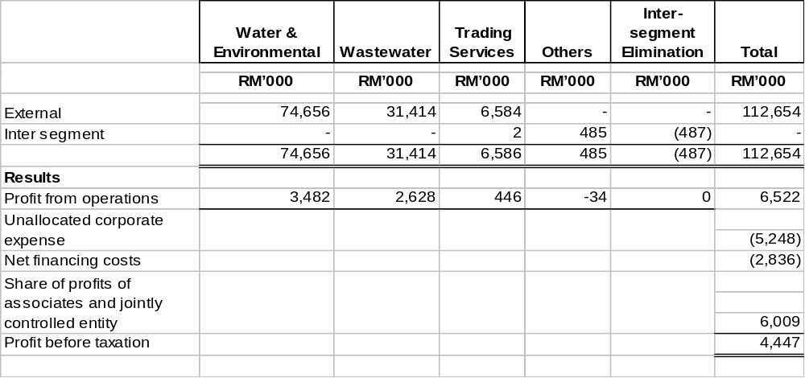

- Valuations of Property, Plant and Equipment

There was no revaluation of property, plant and equipment during the cumulative quarter ended 30 June 2005. The valuation of land and buildings have been brought forward without amendment from the previous annual audited report.

- Material Events Subsequent to the End of the Interim Period

There were no material events subsequent to the end of the interim period up to 12 August 2005 (being the last practicable date which is not earlier than 7 days from the date of issue of this quarterly report), that have not been reflected in the financial statement for the interim period.

- Effect of Changes in the Composition of the Group

The changes in the composition of the Group for the cumulative quarter ended 30 June 2005 are as follows:-

(i) Salcon Berhad had acquired a wholly owned subsidiary, Salcon Yunnan (HK) Limited (formerly known as Salcon Linqu (Hong Kong) Limited), a company incorporated in Hong Kong on 30 December 2004 for a cash consideration of US$1,000 comprising 1,000 ordinary shares of US$1 per share. This change had no material impact on the Group for the cumulative quarter to-date.

(ii) On 2 November 2004, Salcon Engineering Berhad redeemed 6,600 preference shares in Emas Utilities Corporation Sdn Bhd, an associated company, at its cost of RM1,000 each. The preference shares were originally issued at a nominal value of RM1 and a premium of RM999 per share. This change had no material impact on the Group for the cumulative quarter to-date.

(iii) Salcon Berhad (SB) had on 17 February 2005, acquired a wholly owned subsidiary, Salcon Linyi (HK) Limited, a company incorporated in Hong Kong with a paid up capital of HK$1.00 divided into 1 share of HK$1.00 each. This change had no material impact on the Group for the cumulative quarter to-date.

- Changes in Contingent Liabilities/Contingent Assets

The changes in contingent liabilities since the last annual balance sheet date as at 31 July 2004 to 12 August 2005 (the latest practicable date which is not earlier than 7 days from the date of issue of this quarterly report) are as follows:-

 |  | Increase/
 |  | (Decrease)
 |  | RM'000
Bank guarantees given to third parties relating to performance, tenders and advance payment bonds |  | (30,631)

- Trade and other receivables

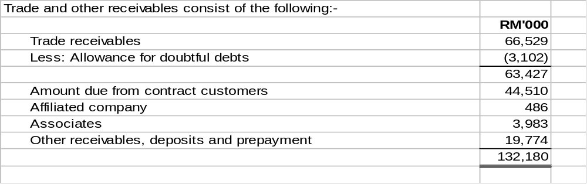

- Trade and other payables
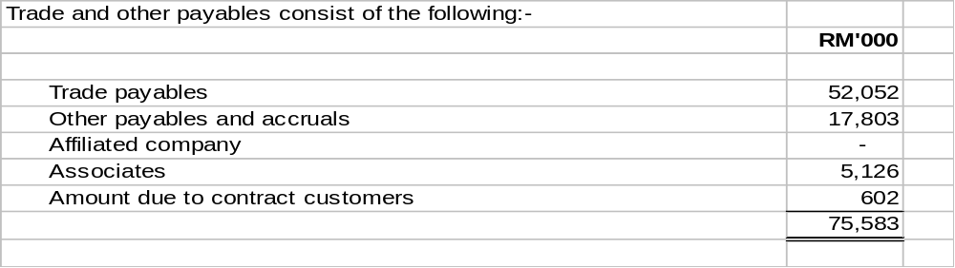

- Net tangible assets (NTA) per share

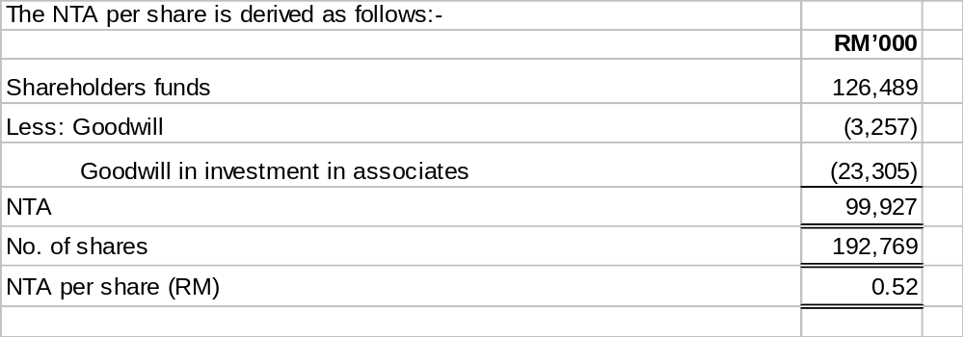

[THE REST OF THIS PAGE IS INTENTIONALLY LEFT BLANK]

ADDITIONAL DISCLOSURE PURSUANT TO CHAPTER 9, PART K OF THE LISTING REQUIREMENTS OF THE BURSA MALAYSIA SECURITIES BERHAD

- Taxation
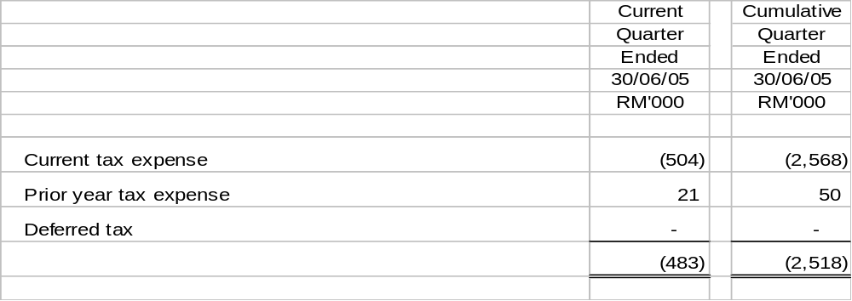
The effective tax rate of the current and cumulative quarter ended 30 June 2005 is higher than the statutory tax rate due mainly to the absence of Group relief for losses incurred by certain subsidiaries.

- Sale of Unquoted Investments and/or Properties

There were no disposals of unquoted investments or properties during the cumulative quarter ended 30 June 2005.

- Purchase or Disposal of Quoted Investments

There were no purchases or disposals of quoted investments during the cumulative quarter ended 30 June 2005.
Total investments in quoted securities as at 30 June 2005 are as follows:

 | RM'000
At cost | 175
At book value | 32
At market value | 25

- Status of Corporate Proposals

(i) On 13 April 2005, Salcon Engineering Berhad (“SEB”), a wholly owned subsidiary of the Company, has entered into a conditional share sale agreement with M. D. Construction Sdn. Bhd (“MD”) for the proposed acquisition of 760,000 ordinary shares of RM1.00 each in Wawasan R & R Builders Sdn. Bhd. (R & R), representing 100% equity interest in R & R for a total cash consideration of RM15,000,000.

The completion of the proposed acquisition is subject to satisfactory completion of the due diligence exercise on R & R and the approval of the Foreign Investment Committee (FIC).

FIC approval was obtained on 17 June 2005 and the due diligence exercise is still currently being carried out.

The timeline for the completion of the proposed acquisition has lapsed on 13 July 2005. However, both parties to the proposal have on 3 August 2005 mutually agreed to extend the timeline for another 3 months to 12 October 2005.

(ii) Salcon Water (HK) Limited, a wholly owned subsidiary of the Company has on 22 April 2005 entered into a conditional Transfer-Operate-Transfer agreement with the Construction Bureau of Changle County, Weifang Municipality, Shandong Province, People's Republic of China to acquire the Changle sewage treatment plant and related facilities, for a total cash consideration of RMB18.0 million.

The completion of the proposed acquisition is subject to satisfactory completion of the due diligence exercise and the approval of the registration and setting up of a new local Chinese company to undertake the project.

The due diligence exercise is currently under review and the approval on the registration and setting up of the new local Chinese company has yet to be obtained.

- On 7 July 2005, Salcon Berhad (“the Company”) has announced a Proposed Private Placement of up to 19,276,860 new Salcon ordinary shares of RM0.50 each representing ten percent (10%) of Salcon’s existing issued and paid-up share capital ("Proposed Private Placement").

The Proposed Private Placement together with the listing of and quotation for the new Salcon ordinary shares of RM0.50 each, to be issued pursuant to the Proposed Private Placement, on the Main Board of Bursa Malaysia Securities Berhad (“Bursa Securities”) were approved by the Securities Commission ("SC") via its letter dated 29 July 2005 subject to the following conditions:

    - Affin Merchant/the Company should disclose details of the proposed utilisation of proceeds from the Proposed Private Placement, which is intended for working capital, in an announcement to Bursa Securities;

    - Affin Merchant should submit to the SC the list of placees, the number of shares placed to them and the issue price of the placement shares, upon the completion of the Proposed Private Placement;

- Affin Merchant should inform the SC upon completion of the Proposed Private Placement; and

- Affin Merchant/the Company should fully comply with the requirements of the Policies and Guidelines on Issue/Offer of Securities in implementing the Proposed Private Placement.

Further, vide the same SC's letter, the SC also approved the Proposed Private Placement pursuant to the Foreign Investment Committee's Guideline on the Acquisition of Interests, Mergers and Take-Overs by Local and Foreign Interests.

On 9 August 2005, the Board of Directors of the Company has determined 9 August 2005 as the price-fixing date for up to 19,276,860 Placement Shares to be issued pursuant to the Proposed Private Placement. Accordingly, the issue price has been fixed at RM0.51 for one (1) Placement Share, after having taken into consideration the five (5)-day weighted average market price of the ordinary shares of the Company up to 8 August 2005 of RM0.57. The issue price of RM0.51 per (1) Placement Share represents a discount of 10.5% over the five (5)-day weighted average market price of the Company up to 8 August 2005 of RM0.57.

- Chenggong Salcon Water Co. Ltd. has been incorporated and was issued a Temporary Operating License by Administrative Bureau of Industry & Commerce, Kunming City, Yunnan Province. Salcon Berhad’s proposed shareholding in this company is 60% and the proposed equity will be held via its wholly-owned subsidiary, Salcon Yunnan (HK) Limited. However, the registered equity of the company has yet to be issued, pending the conditions precedent to be met pursuant to the Concession Agreement.

- Group Borrowings and Debt Securities

Total Group borrowings as at 30 June 2005 are as follows:

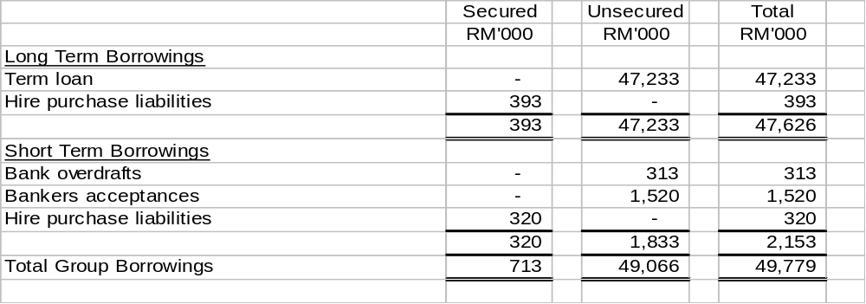
Included in the above Group borrowings are the following loans denominated in Chinese Renminbi (RMB) :

 | Foreign currency |  | Equivalent
 | RMB'000 |  | RM'000
Long Term Borrowings (Unsecured) | 4,801 |  | 2,233

- Off Balance Sheet Financial Instruments

The Group does not have any financial instruments with off balance sheet risk as at 12 August 2005 (being the last practicable date which is not earlier than 7 days from the date of issue of this quarterly report).

- Changes in Material Litigation

The material litigations as at 12 August 2005 (being the last practicable date which is not earlier than 7 days from the date of issue of this quarterly report) are as follows:

- Salcon Engineering Berhad ("SEB") had on 29 September 1999 commenced legal action in the Kuala Lumpur High Court against Citramuda Sdn Bhd ("Citramuda") and Readybuilt (M) Sdn Bhd ("Readybuilt"), being parties to an unincorporated consortium ("the Consortium"), for the sum of RM2,171,488.57 due to works carried out by SEB pursuant to a subcontract agreement dated 5 November 1996.

SEB obtained judgement in default against Citramuda on 15 December 1999. Citramuda was wound up by order of the Kuantan High Court on 20 June 2000. SEB attempted to enforce the judgement by way of garnishee proceedings against Kuala Lumpur International Airport Berhad, the employer of the Consortium but was not successful.

Readybuilt had since been wound-up on 6 February 2004. Subsequently, SEB had filed its Proof of Debts to the Official Receiver on 28 June 2004 and had proceeded with the filing of its Supporting Affidavit on 1 March 2005 in accordance with Section 226(3) of the Companies Act, 1965 in order to obtain judgement. The case is now pending creditors meeting.

- MQS Engineering Sdn Bhd ("MQS") instituted legal proceedings in Shah Alam High Court against SEB for an amount of RM4,745,035 pursuant to a Novation Agreement and Settlement Agreement both dated 23 November 2000.
- In response, SEB has successfully applied to amend the Defence and to include a Counter-Claim of RM1,780,004.00 in the suit. The Court has fixed the suit for further case management on 16 September 2005 and the full trial for the Claim and Counter-Claim is fixed on 10 May to 12 May 2006.

- Material Changes in the Results of the Current Quarter compared to that of the Preceding Quarter

Compared to the preceding quarter, the Group’s revenue and profit before taxation for this two month period decreased by RM11.7 million (30%) and RM0.7 million (47%) respectively due to lower revenue and profit before taxation as compared to the preceding quarter with a period of three months from 1 February 2005 to 30 April 2005.

- Review of Performance of the Company and its Principal Subsidiaries

For the quarter under review, the Group recorded revenue and profit before tax of RM26.8 million and RM0.8 million respectively. No comparison was made against the previous corresponding quarter as the Group has changed its financial year-end from the existing 31 July to 31 December as detailed in Note A1.
For the cumulative quarter to date, the Group recorded revenue and profit before tax of RM112.7 million and RM4.4 million respectively. No comparison was made against the previous corresponding period as the Group has changed its financial year-end from the existing 31 July to 31 December as detailed in Note A1.
The decline in both revenue and profitability reflect the slow pace in the industry.

- Prospects for the Current Year

With the prevailing market conditions, the Board expects the remaining months of the financial year for the contracting sector to be challenging. However, the long-term Operation and Maintenance contracts and concessions will provide a stable revenue stream for the Group.

The Group continues to pursue water and wastewater projects within Malaysia focusing on non-revenue water, Operation & Maintenance services and sewerage projects. In China, the Group would concentrate on concessions operations whilst in other countries, the focus will be on contracting as well as privatisation opportunities.

- Variance of Profit Forecast / Profit Guarantee

Not applicable to the Group.

- Proposed Dividend

No dividend has been declared nor recommended for the cumulative quarter ended 30 June 2005.

- Earnings Per Share

The basic and diluted earnings per share have been calculated based on the consolidated net profit attributable to ordinary shareholders for the period and the weighted average number of ordinary shares outstanding during the period as follows:

Basic earnings per share

 |  |  |  |  |  |  |  |  |  |  |  | Current  Quarter  Ended |  |  |  |  |  |  | Comparative  Quarter  Ended |  |  |  |  | Cumulative
 |  |  |  |  |  |  |  |  |  |  |  |  |  |  |  |  |  |  |  |  |  |  |  | Quarter
 |  |  |  |  |  |  |  |  |  |  |  |  |  |  |  |  |  |  |  |  |  |  |  | To-date
 |  |  |  |  |  |  |  | 30/04/05 |  |  | 30/04/04 |  |  | 30/04/05 |  |  | 30/04/04
 |  |  |  |  |  | Net profit attributable to ordinary shareholders (RM'000) |  | 230 |  |  | 217 |  |  | 567 |  |  | 11,189
 |  |  |  |  |  | Weighted average number of ordinary shares
 |  |  |  |  |  | Issued ordinary shares at beginning of period ('000) |  | 192,769 |  |  | 191,418 |  |  | 192,769 |  |  | 162,062
 |  |  |  |  |  | Effect of shares issued during the period ('000) |  | - |  |  | 978 |  |  | - |  |  | 27,655
 |  |  |  |  |  | Weighted average number of ordinary shares ('000) |  | 192,769 |  |  | 192,396 |  |  | 192,769 |  |  | 189,717
 |  |  |  |  |  | Basic earnings per share (sen) |  | 0.12 |  |  | 0.11 |  |  | 0.29 |  |  | 5.90
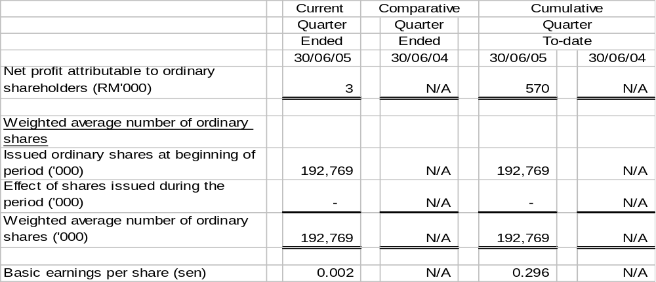

Note:
The comparative figures are not applicable due to the change of financial year as detailed in Note A1.

[THE REST OF THIS PAGE IS INTENTIONALLY LEFT BLANK]

Diluted earnings per share

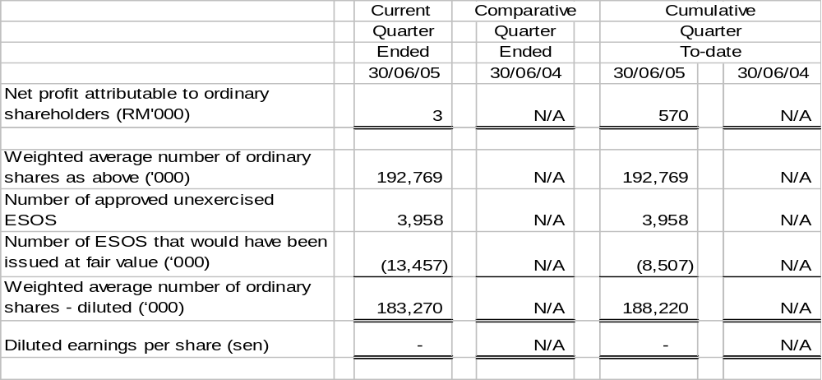The diluted earnings per share for the current quarter and cumulative quarter to-date are not shown as the effect is anti-dilutive.

Note:
The comparative figures are not applicable due to the change of financial year as detailed in Note A1.

- Comparative figures

The comparative figures are not applicable due to the change of financial year as detailed in Note A1.

ON BEHALF OF THE BOARD

DATO’ LIM SEE TEOK
Chief Executive Officer/ Director

Selangor Darul Ehsan
19 August 2005

